Whole traingle at tilted earth view

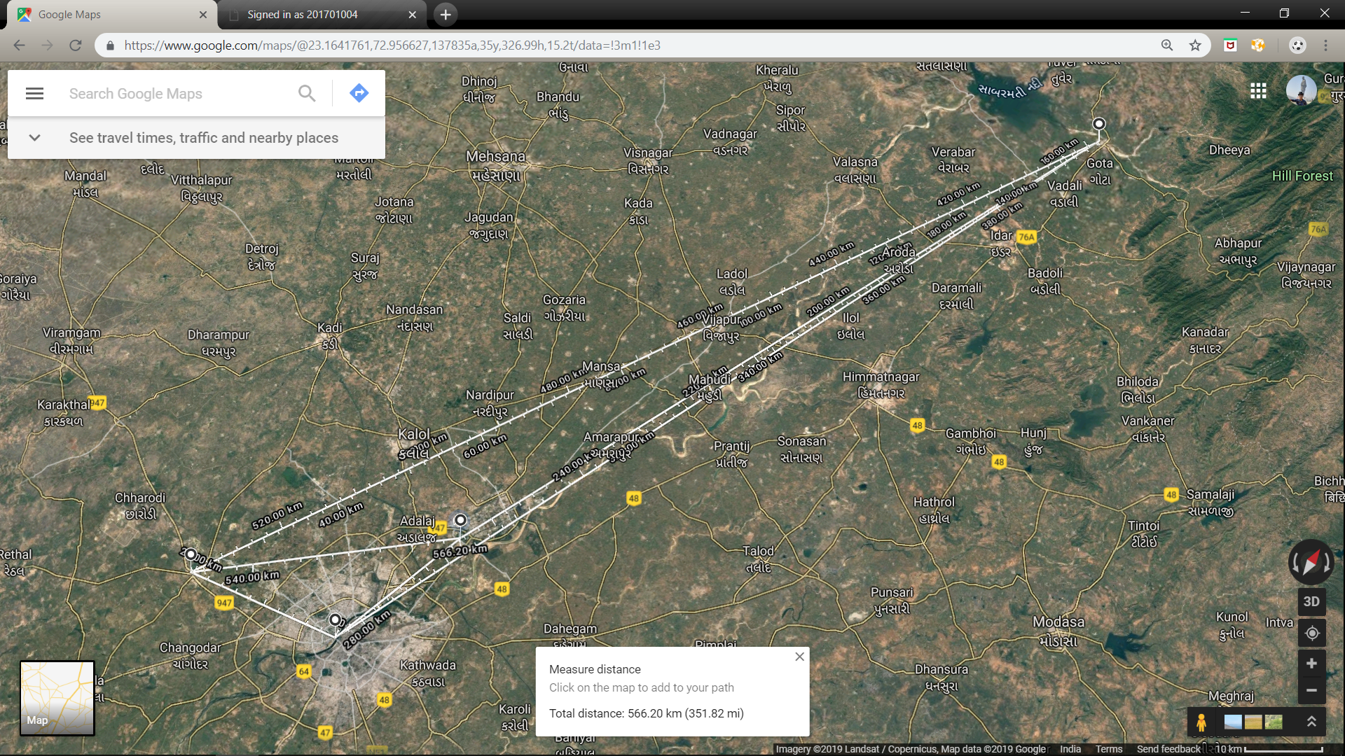

sanand

Khedbhrama

Ahmedabad

Whole traingle

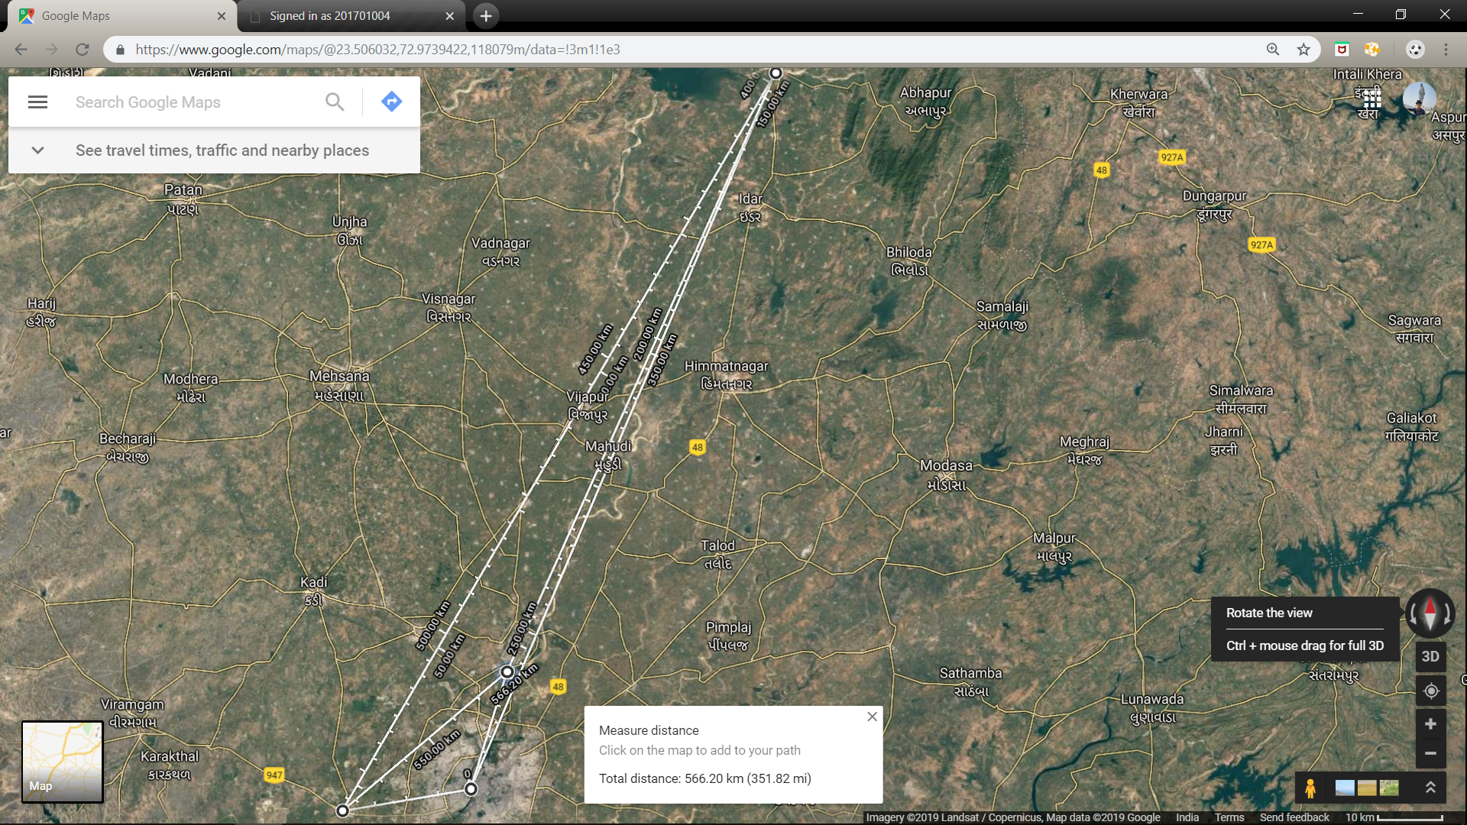

Khedbhrama

Ahmedabad

sanand

After zoom

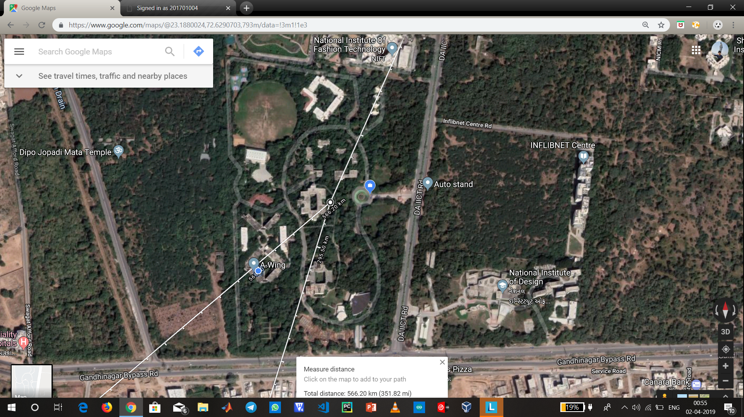

Khedbhrama

Khedbhrama

Ahmedabad

sanand

sanand

Ahmedabad